

CASSYS: Canadian Solar System Simulation Software

Interface User Manual

*Canadian Solar Inc. Operations and Maintenance*

*545 Speedvale Ave. West Guelph, ON N1K 1E6*

*Tel: +1 519 837 1881 ext. 2113 Mobile: +1 519 240 7513*

Table of Contents

1. Interface Layout 1

2. Creating a New Site Definition 2

Intro Page 2

Site Page 3

Orientation and Shading Page 5

Losses Page 7

Soiling Page 7

Transformer Page 8

Climate File Page 9

Output File Page 10

3. Running the Simulation 13

4. Loading a Site Definition 14

5. Chart Building 15

6. Adding New PV Modules and Inverters 16

7. Saving a Report 18

8. CASSYS Troubleshooting 18

Simulation program could not be found: 18

Unable to run simulation, the following fields could not be found: 19

The Available Output List is not consistent with the current version: 19

Simulation error: “Not recognized as a valid DateTime” 19

Enable Macro Page Visible: 21

**Table of Figures**

Figure 1: Example of User-Defined cells 1

Figure 2: Example of Calculated cells 1

Figure 3: Example of cells containing database values 1

Figure 4: Example of Links 1

Figure 5: Navigation Panel 1

Figure 6: Intro Page - Creating a new site definition 2

Figure 7: Site Page – Overview 3

Figure 8: Site Page - Yearly Albedo 4

Figure 9: Site Page - Monthly Albedo 4

Figure 10: Orientation and Shading Page - Fixed Titled Plane 5

Figure 11: Orientation and Shading Page - Unlimited Rows 5

Figure 12: System Page - Specifying Number of Sub-Arrays 6

Figure 13: PV Module Selection GUI 6

Figure 14: Inverter Selection GUI 6

Figure 15: Losses Page – Overview 7

Figure 16: Soiling Page - Yearly Soiling Losses 7

Figure 17: Soiling Page - Monthly Soiling Losses 8

Figure 18: Transformer Page – Overview 8

Figure 19: Input File Page - Overview 9

Figure 20: Input File Page - Example Input File 10

Figure 21: Output File Page Overview 11

Figure 22: Output File Page - Selecting Output Parameters 12

Figure 23: Simulation Console 13

Figure 24: Loading a Site Definition 14

Figure 25: Chart Builder Sheet – Declaring number of y-values 15

Figure 26: Adding PV Module or Inverters 16

Figure 27: Add PV Module GUI 16

Figure 28: Add Inverter GUI 16

# Interface Layout

* User-defined cells have a white background and have a border around the cell.

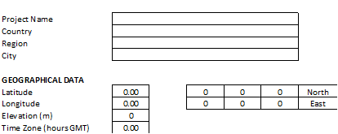

Figure : Example of User-Defined cells

* Cells containing calculated values have a purple background and a border around the cell.



Figure : Example of Calculated cells

* Cells containing values from the database have a light blue background.



Figure : Example of cells containing database values

* All links have no underline, are colored black, and are in bold print.

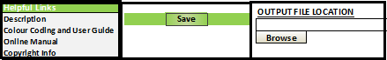

Figure : Example of Links

* On each page is a Navigation panel used to go to the previous page, the Intro sheet, or the next page respectively.



Figure : Navigation Panel

# Creating a New Site Definition

## Intro Page

On the Intro page click ‘New’ to clear out all the fields. After all the fields are cleared, you can click on one of the links on the side to start entering information about the solar site. It is recommended to start on the ‘Site’ page first.

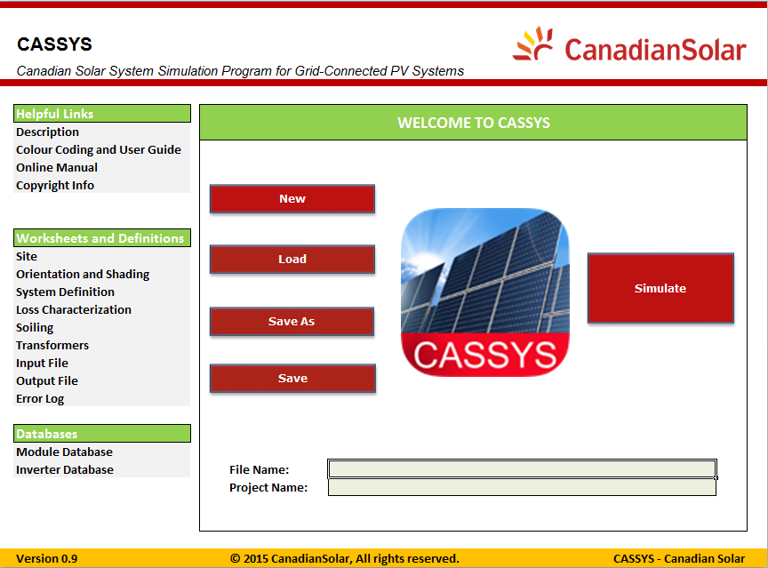

Figure : Intro Page - Creating a new site definition

## Site Page

Fill out all of the fields except for albedo. The albedo can be defined as either a single yearly value or have separate values for each month. Click the ‘Frequency’ box for a drop-down list and select either ‘Yearly’ or ‘Monthly’ based on your needs.

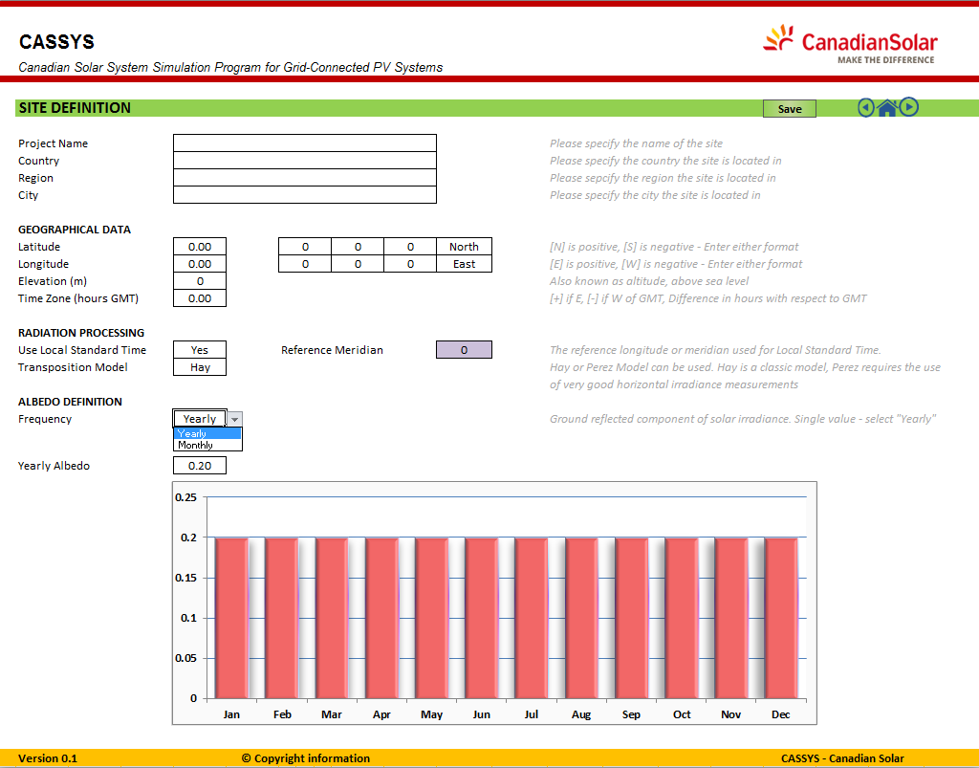

Figure : Site Page – Overview

The chart and rows will update based on your selection, as shown below:



Figure : Site Page - Yearly Albedo



Figure : Site Page - Monthly Albedo

## Orientation and Shading Page

On the Orientation and Shading page, use the drop down menu to choose an array type. Currently CASSYS supports the choice of Fixed Tilted Plane or Unlimited Rows. The type of array you choose will show or hide the fields relevant to the array type. If Unlimited Rows is selected you will also have the option to use cell based shading effect. Select in the drop down whether you wish to use this or not. Afterwards, fill in the rest of the fields.

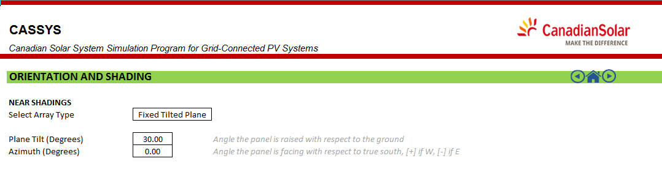

Figure : Orientation and Shading Page - Fixed Titled Plane

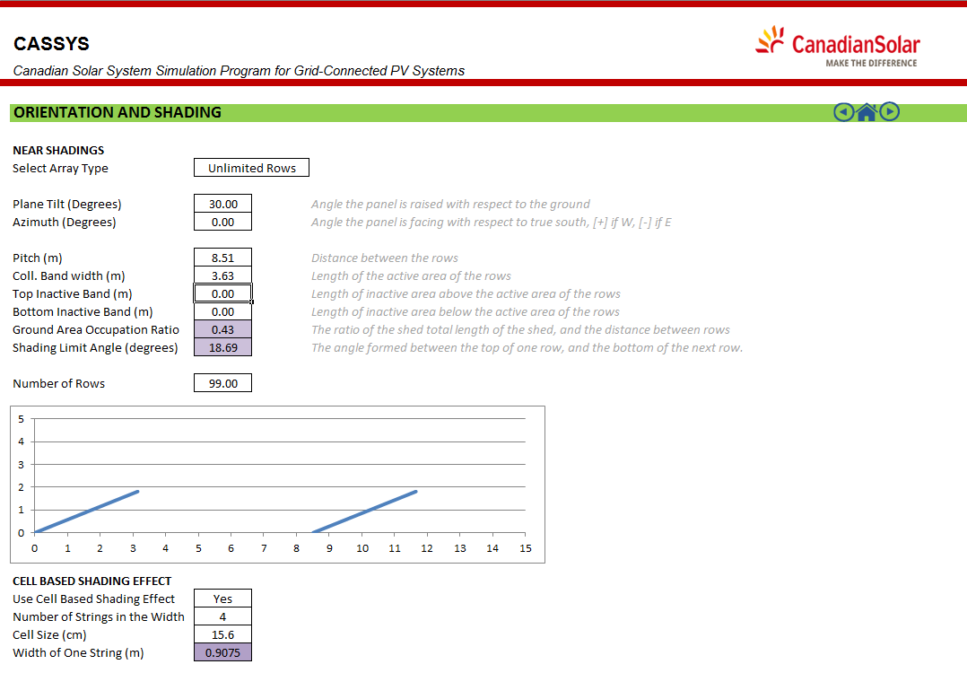

Figure : Orientation and Shading Page - Unlimited Rows

System Page

On the System page you can specify the number of sub-arrays in a field. To choose an array PV module or inverter, you must click the ‘Search’ link and pick the manufacturer, model and data source of the module or inverter using the list in the GUI. Fill in the loss fraction fields as well as the other user defined fields for the PV modules and inverters. *(To add a new module or inverter, see* *Add Module or Inverter**)*

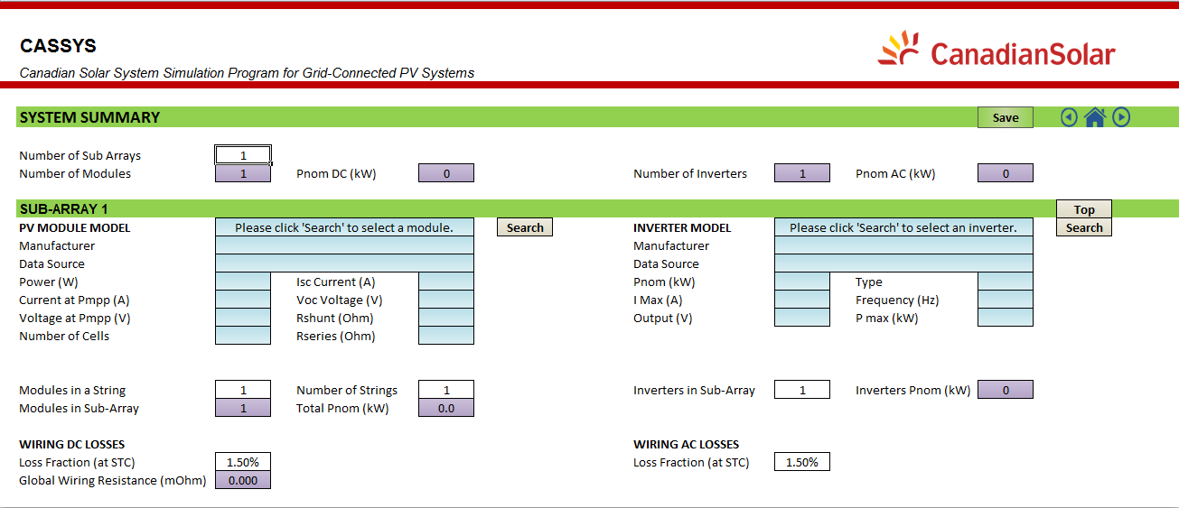

Figure : System Page - Specifying Number of Sub-Arrays

|  |  |
| --- | --- |
|  |  |
| Figure 13: PV Module Selection GUI | Figure 14: Inverter Selection GUI |

## Losses Page

On the Losses page, first set ‘Use Measured Module Temperature’ to TRUE or FALSE by clicking on it and using the drop-down list. This field should be set to TRUE if you can provide reliable module temperature data in the input file. If the field is set to FALSE, then heat loss factors must be provided and the Faiman model will be used during simulation.

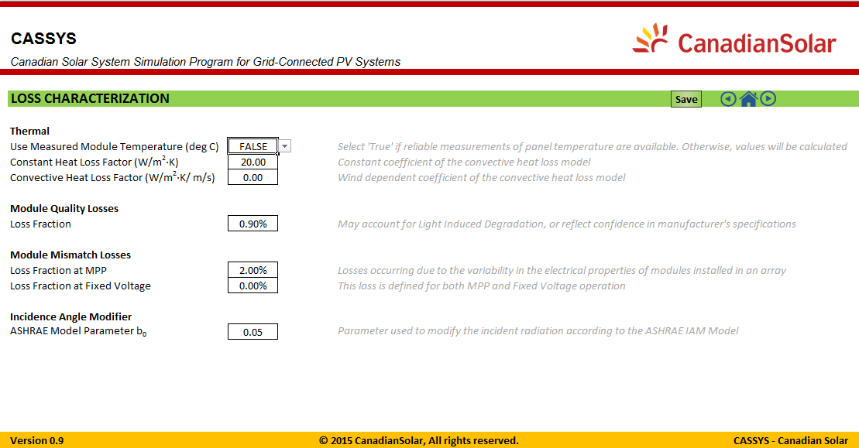

Figure 15: Losses Page – Overview

## Soiling Page

The Soiling page, like the Orientation and Shading page, has a drop-down list that shows or hides the yearly and monthly soiling losses depending on what is chosen.



Figure : Soiling Page - Yearly Soiling Losses



Figure : Soiling Page - Monthly Soiling Losses

## Transformer Page

On the transformer page, fill in the the nominal power of the transformer, nominal voltage, iron loss and resistive loss. In the drop down list choose whether or not it is disconnected at night. This sheet contains a graph to illustrate the iron and resistive losses based on the amount of power being fed into the transformer.

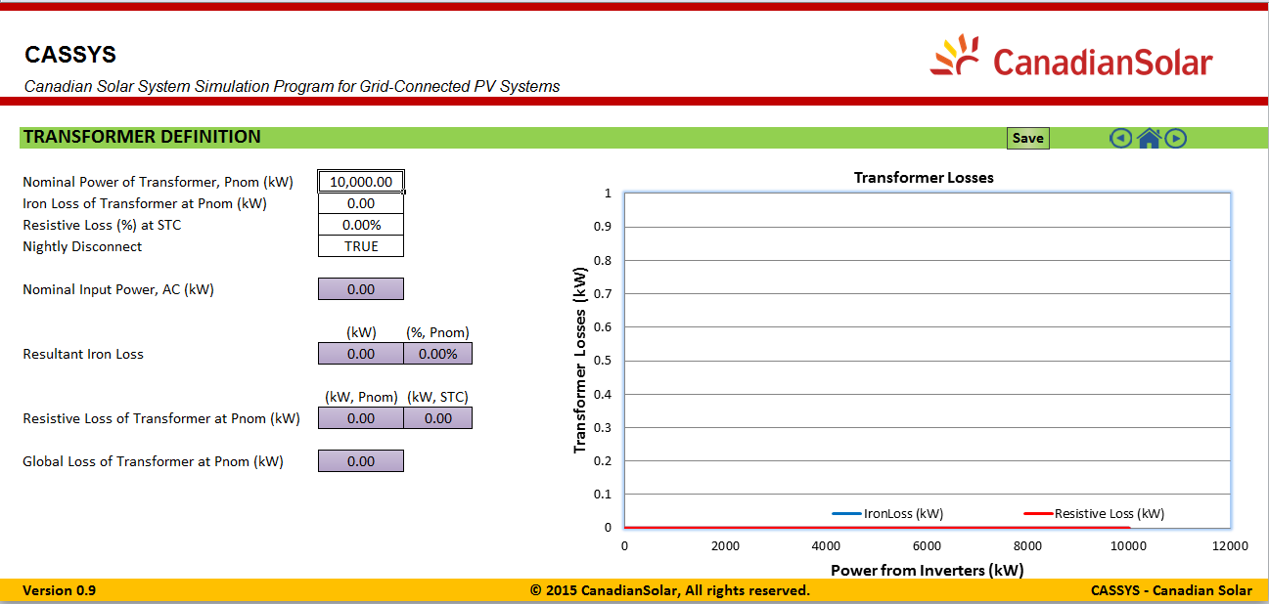

Figure : Transformer Page – Overview

## Climate File Page

On the Input File page, click the browse link and select the input file (in .csv format) for the simulation from the dialog box. Alternatively, you can type in the path to the input file in the field. If the file is valid, a preview of the first 11 lines of the input file should appear in the bottom half of the page. In the delimiter field, type in the delimiter used to separate the cell values of the csv file. Enter the number of rows to skip in the input file (if the numerical data begins on line 3, then change the value of ‘Rows to Skip’ to 2 so that CASSYS starts reading the file from the third row; the column headers are always assumed to be on line 1 and skipped over). Finally, in the Time Series Characteristics box select when the time intervals are averaged at (Beginning, Middle, or End) from the drop-down list and enter the nominal time step.

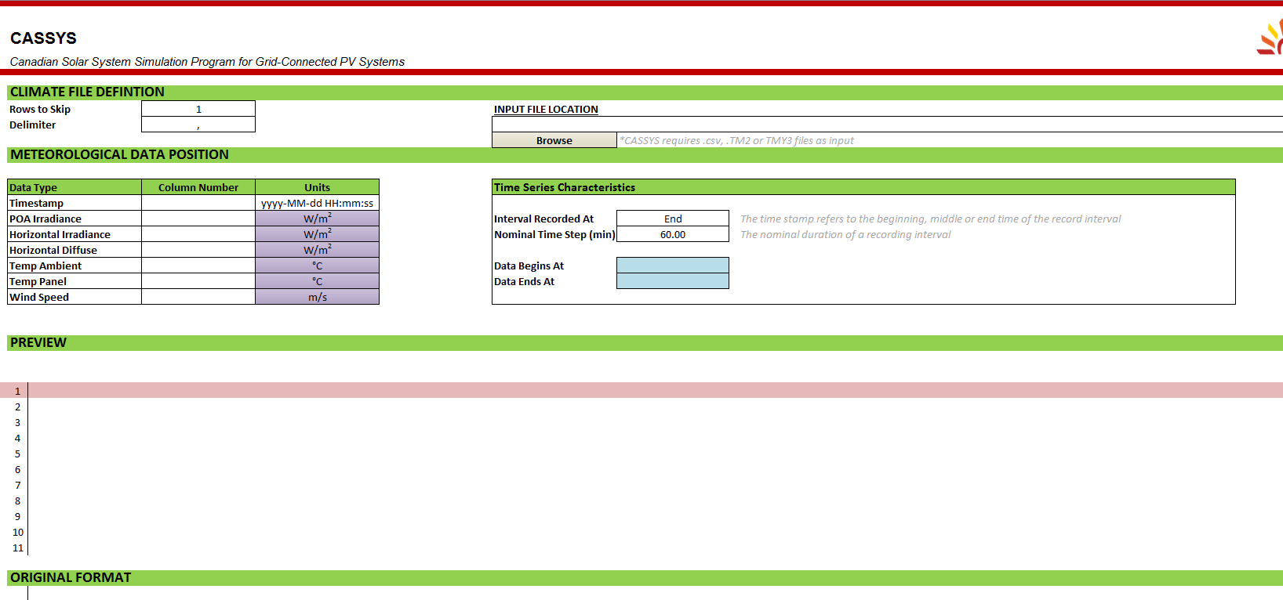

Figure : Input File Page - Overview

Once you select an input file, the following preview should appear:

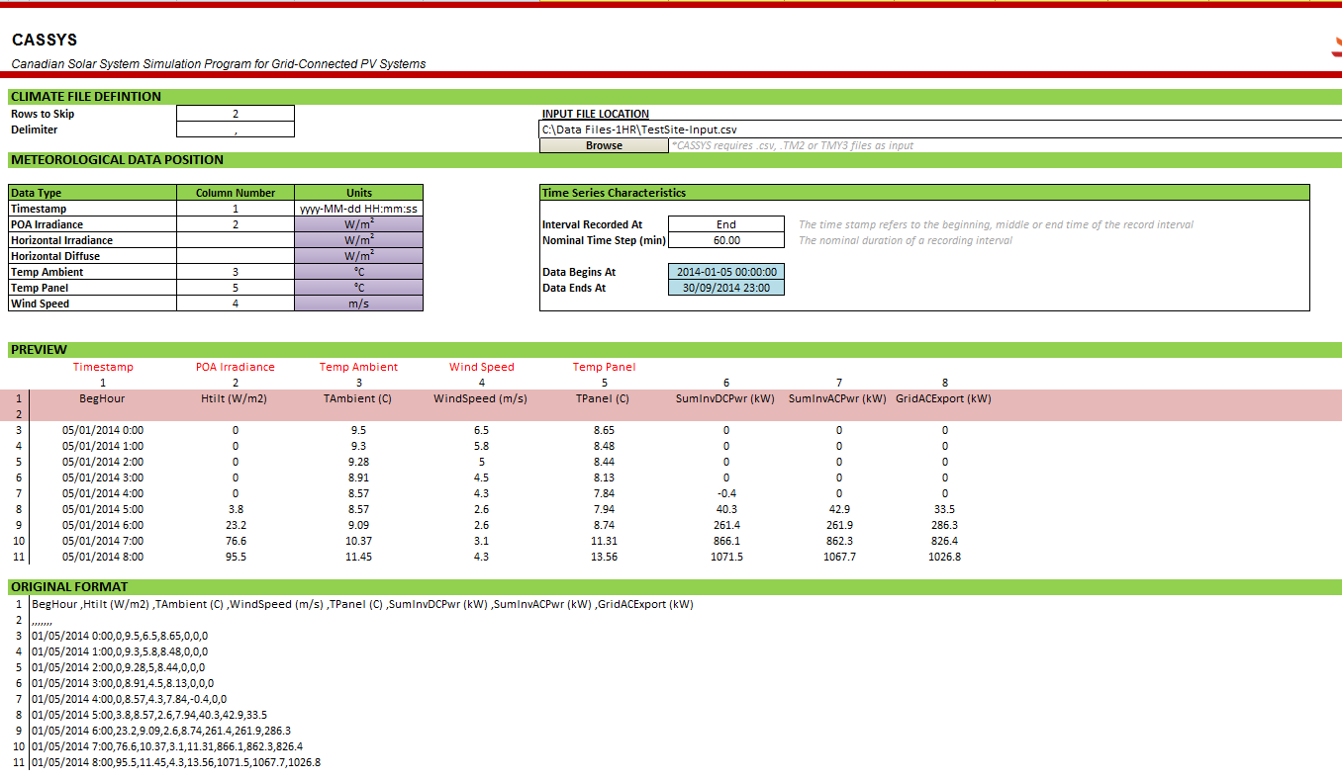

Figure : Input File Page - Example Input File

Enter the corresponding column number of each input parameter for the input file you have provided. For example, ‘TAmbient’ is shown as column 3 in the input file preview. Simply enter a ‘3’ into the Column Number box next to Temp Ambient; a header label should appear for you to confirm if you selected the correct column. If you do the same for the Timestamp column (in this case column 1) a preview for the beginning and end dates will appear so that you can verify whether or not the input file data is correct. Also notice that the ‘Rows to Skip’ field in the top left corner is set to 2, since the data starts on the third line as seen in the preview.

## Output File Page

The output file page allows you to specify the parameters which appear in the output file and the Summary sheet after running a simulation. To select the output file where the simulation data is inserted, click ‘Browse’ or alternatively type in the file path manually. On the left side, you can collapse or expand sections by clicking directly on the ‘+’ or ‘-‘ buttons.

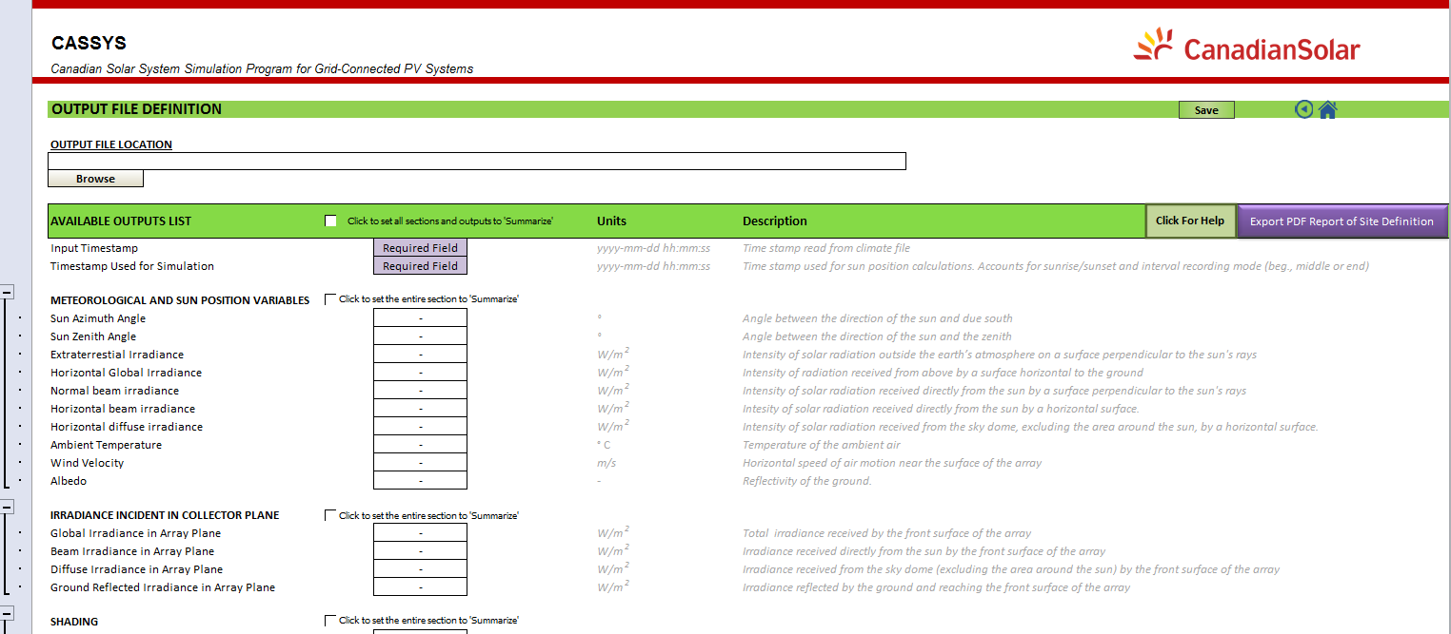

Figure : Output File Page Overview

To specify a desired output parameter that will appear in the output file, change its corresponding box to the right to ‘Yes’. There are multiple ways to select output parameters, as shown below:

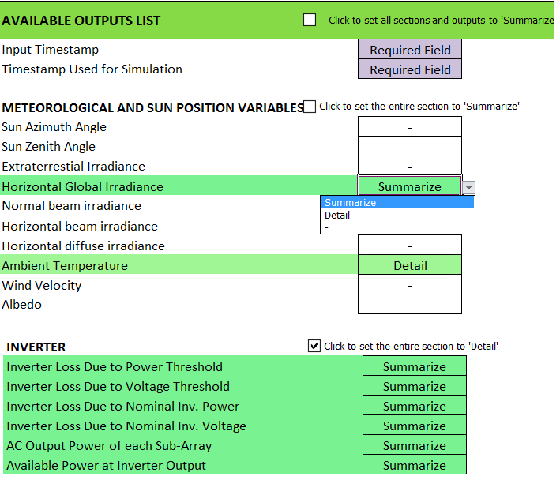

Figure : Output File Page - Selecting Output Parameters

Figure 18 demonstrates the selection of parameters with either individual selections or a checkbox. To select outputs individually, click on the box to the right of an output parameter and select ‘Summarize’, ‘Detail’ or ‘-‘ from the drop-down list. If a particular section is of interest/unwanted, you can check the checkbox next to the section title to set all the parameters in that section to ‘Summarize’, `Detail’, or ‘-‘, as shown in Figure 23. Last, if you would like to change all outputs at once, check the checkbox at the top of the page next to ‘Available Outputs List’, which will change all output parameters at the same time. When an option is selected, the cell row will be highlighted with a bright green or light green, or white based on if Summarize, Detail, or ‘-‘ was selected, respectively.

A brief description of the three options:

1. The ‘Detail’ option will write the simulation results of the selected parameter into the output file.
2. The ‘Summarize’ option not only prints the simulation results into the output file and Results sheet, but the selected parameter will also be summarized on the Summary page by a pivot table using the most logical method (either Sum or Average).
3. Selecting ‘-‘ means that the parameter will be ignored during simulation; no simulated data for this parameter will be output.

At this point, is recommended that you click on the ‘Save’ button on the banner or on the Intro page to save all your site information to a .csyx file, or you can return directly to the Intro page by clicking on the house icon on the banner to simulate the current site.

# Running the Simulation

* To simulate the current site definition, click the Simulate button on the Intro page. If you would like to simulate another site definition that you previously saved as a .csyx file, then load it first (*see* *Loading a Site Definition*) before clicking on Simulate.

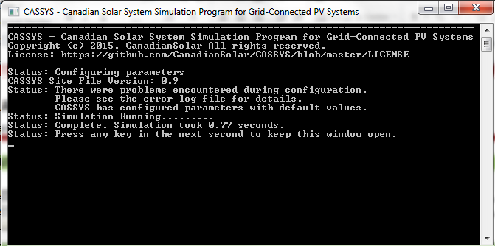

Figure : Simulation Console

* When the simulation is completed, the results page, report page and chart builder page will be unhidden and the site will be loaded onto the interface.
* The results page contains the simulated data which has been saved to the output file.
* The report sheet is a detailed report of the simulated site definition.
* The chart builder allows the user to create charts using the data in the results sheet (*see* *Chart Building*)

# Loading a Site Definition

1. To load a previously saved site definition, go to the Intro sheet and click the load link
2. Select the .csyx file containing the Farm configuration information from the dialog box

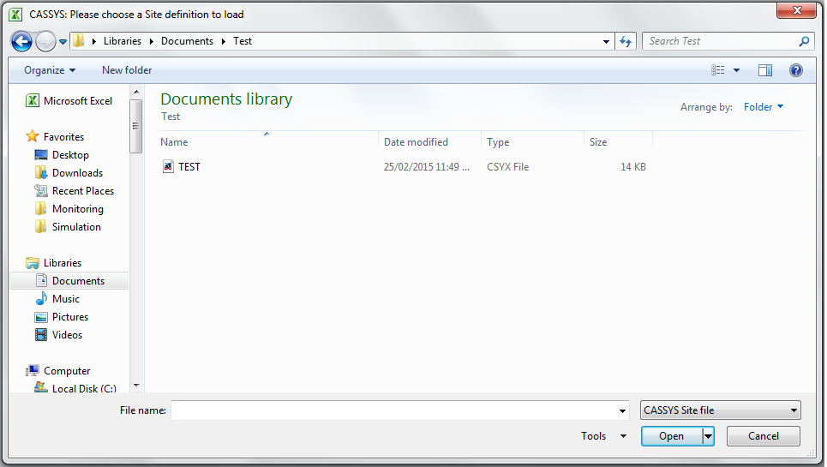

Figure : Loading a Site Definition

# Chart Building

1. To define the number of y values, just select the number from the list in the corresponding chart section
2. To define the x and y values, select them using the x and y values lists

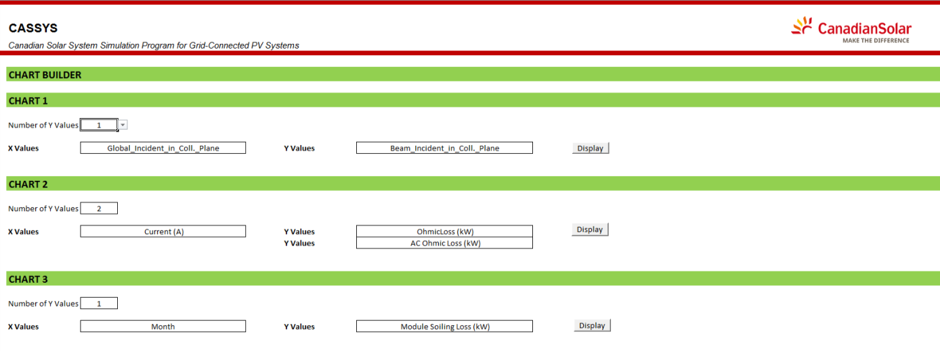

Figure : Chart Builder Sheet – Declaring number of y-values

1. To create the chart click the display button, you will be automatically taken to the new chart when it is completed

# Adding New PV Modules and Inverters

1. You can add or define a new PV Module or Inverter either by using the ‘Add or Import PV module/Inverter’ button at the top of the Database sheets, or on the ‘Search’ userform on the System page. Both buttons will open up the following selection box:

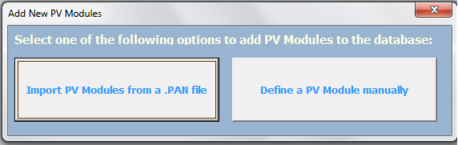

Figure : Adding PV Module or Inverters

The left option allows you to choose a PVSyst PAN file (or OND file in the case of inverters) to import into the CASSYS database. Note that CASSYS only supports OND files before PVSyst version 6 (this restriction does not apply to PAN files). Clicking the option on the right opens the following GUIs:

|  |  |
| --- | --- |
|  |  |
| Figure : Add PV Module GUI | Figure : Add Inverter GUI |

1. A GUI will appear, fill in all of the fields with the appropriate values
2. Creating an Inverter also has the option of choosing between single or multiple curve efficiencies
3. Depending on which efficiency sheet is selected the new inverter will either contain single or multiple efficiency curves
4. Choose you desired efficiency curve format, note that you must define all three of the curves for the multiple curve formats
5. When you are finished click the add button.

# Saving a Report

CASSYS supports a PDF export of the site definition for future reference or when replicating a simulation when a .csyx file is not available to load.

Simply navigate to the Output File page, and click on the ‘Export PDF Report of Site Definition’ button.

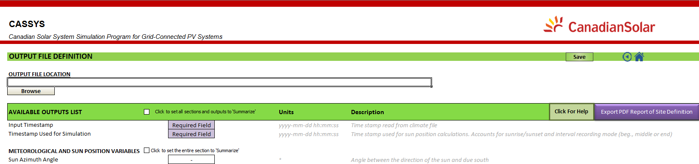

A Browse dialog box should appear. Navigate to the location where you would like the report to be saved, enter the desired filename and click ‘Save’. The report will be exported to the specified location and the file should automatically open for your verification.

# CASSYS Troubleshooting

### Simulation program could not be found:

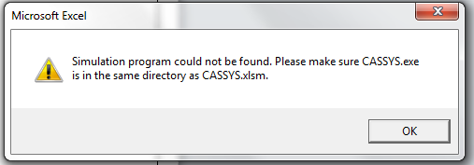

**Error description:**

The program used to run the simulation is separate from the CASSYS interface, and is named CASSYS.exe. If you encounter this message, this means that CASSYS.exe is not in the same directory as the CASSYS interface.

**Solution:**

Place the CASSYS.exe file into the same parent folder or path as the CASSYS interface (for example, if the CASSYS interface (CASSYS.xlsm) is saved in “C:\ExampleFolder\CASSYS.xlsm” then make sure that CASSYS.exe is in the location “C:\ExampleFolder\CASSYS.exe”. If further issues persist or you can not locate CASSYS.exe, then re-download CASSYS from the website.

### Unable to run simulation, the following fields could not be found:

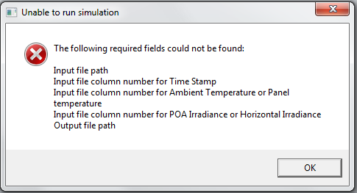

**Error description:**

This error occurs when the Simulate button is clicked but the fields required to run the simulation were not filled in.

**Solution:**

Fill in all of the fields listed by the message with valid inputs, or verify that a file is properly loaded before clicking the Simulate button again.

### The Available Output List is not consistent with the current version:

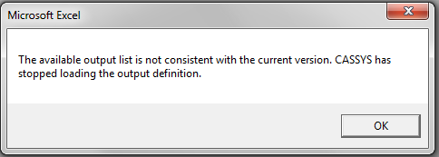

**Error Description:**

The .csyx file is incorrectly defined as the output file list has no parameters.

**Solution:**

Load the .csyx file you were trying to simulate first, click ‘Save’ and then simulate the file again.

### Simulation error: “Not recognized as a valid DateTime”

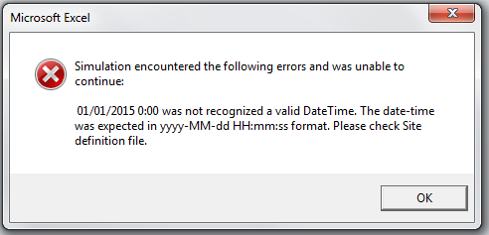

Error Description:

The simulation requires the ‘Timestamp’ column of the input file to be formatted as a date to run.

Solution:

1. First go to the Input File page and ensure that the column number you have inputted for ‘Timestamp’ is correct. The following is a picture of a correctly numbered input file:

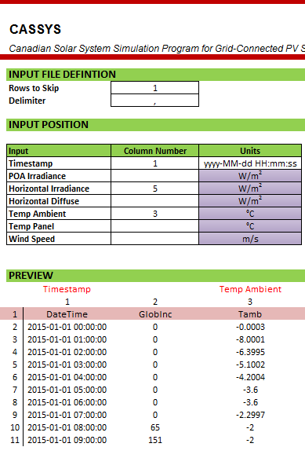

v

1. Next, make sure that the ‘Units’ dropdown box on the ‘Timestamp’ row corresponds to the units provided in the input file (which can be seen from the ‘Original Format’ preview). In the following picture, the format “mm/dd/yyyy hh:mm:ss” should be selected:

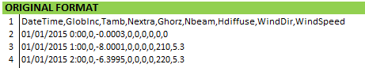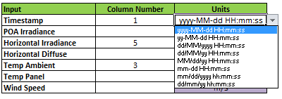

1. Try to run the simulation again. If the simulation fails with the same error again, then the problem lies in the input file itself. Open the input file and make sure that the dates of the ‘Timestamp’ column are in a DateTime format (e.g mm/dd/yyyy hh:mm:ss).
2. Save the input file, close it and run the simulation again. The error should no longer occur.

### Enable Macro Page Visible:



**Error Description:**

If you see this page, it means that macros have not been enabled in your Excel program. Macros are necessary for CASSYS to function, and it is critical that macros are enabled before continuing.

The following page provides several different methods of enabling macros.

**Solution:**

**Excel 2010**

1. **Click on the ‘File’ tab in the top left corner of Excel.**

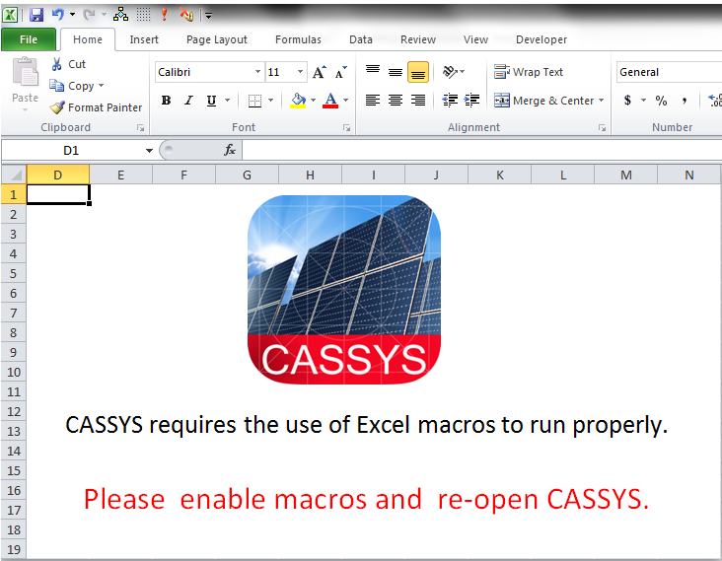

1. **On the left side bar, click on the button named ‘Options’**

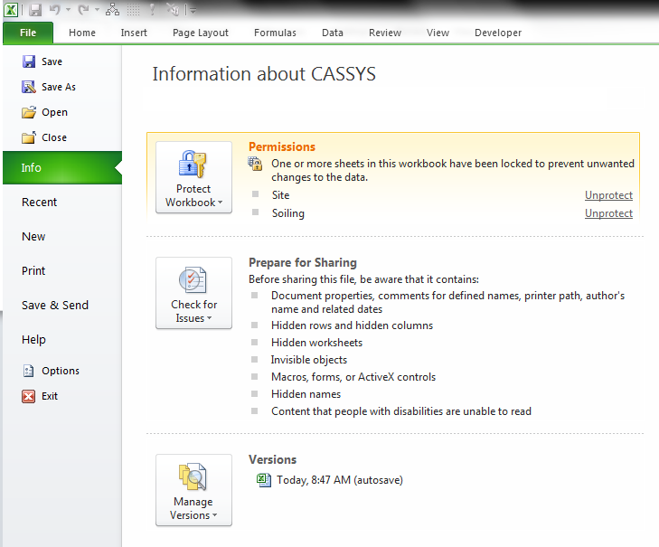

1. **Click on the ‘Trust Center’ Tab and then on ‘Trust Center Settings’**

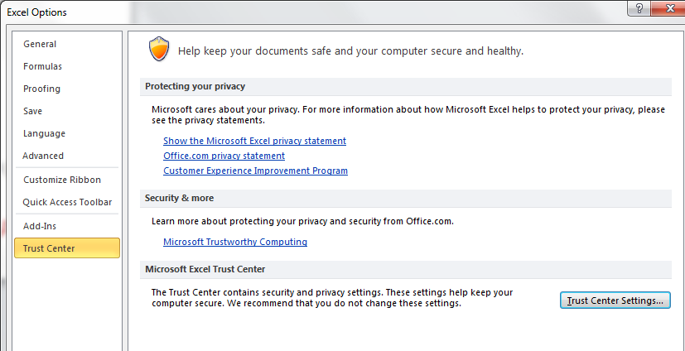

1. Finally, make sure that ‘Enable all macros’ is selected.

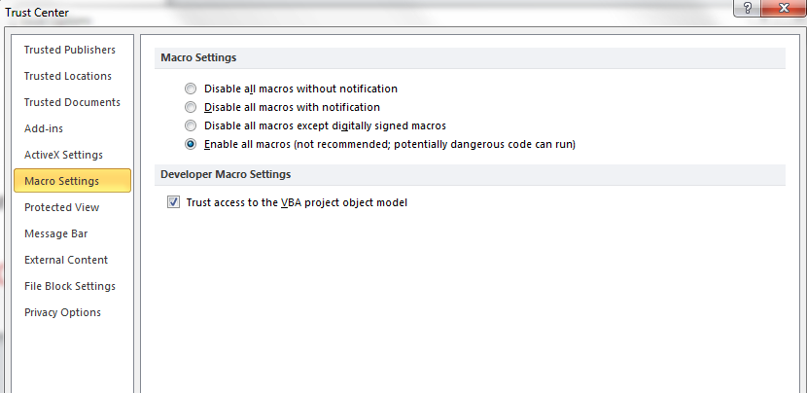

1. Alternatively, if you only want CASSYS macros to run, you can select ‘Disable all macros with notification’ in the window above and when CASSYS opens, click ‘Enable content’.

